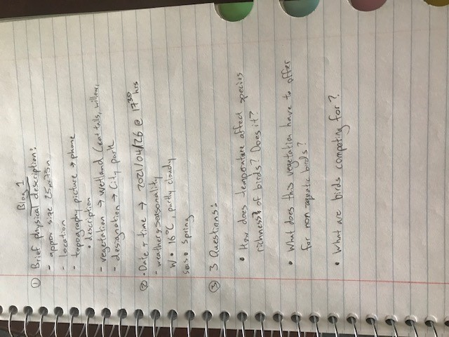
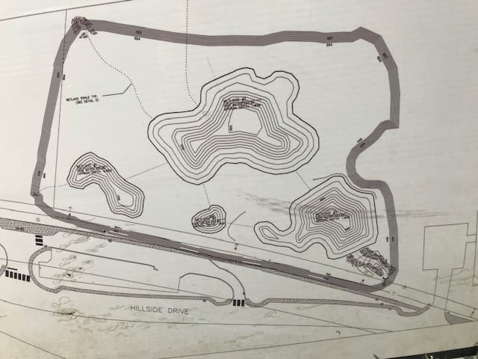

Figure 2: Topographical Map Photo
Figure 1: Written Field Journal Entry

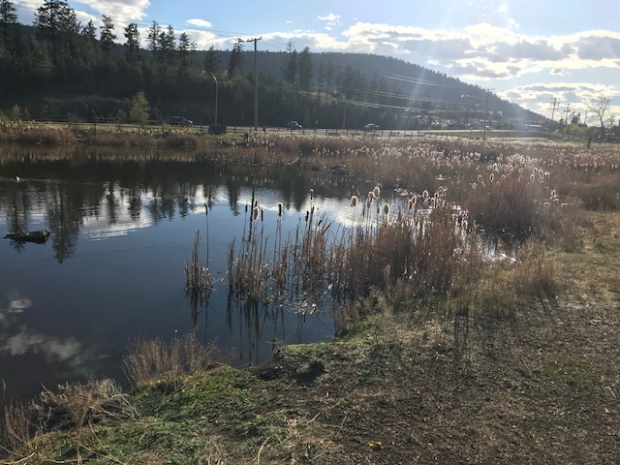
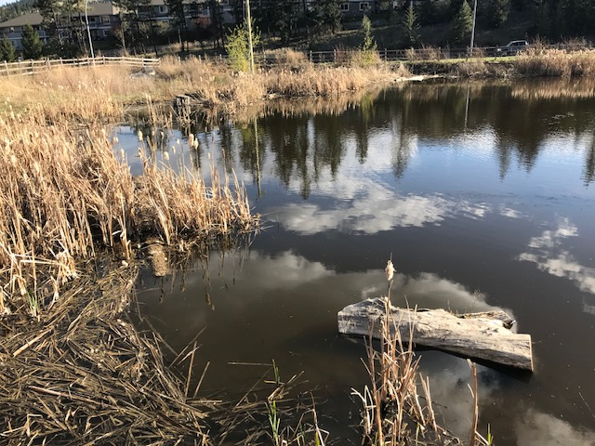
Figure 3: Photos of Dufferin Park Wetland – Left Side

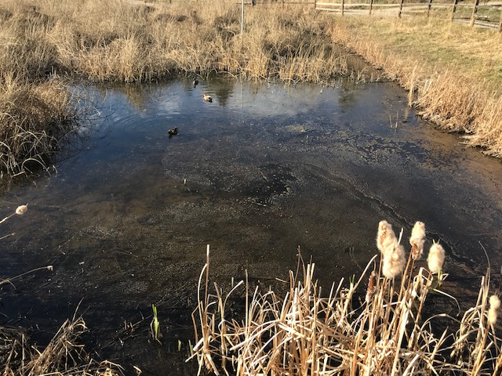
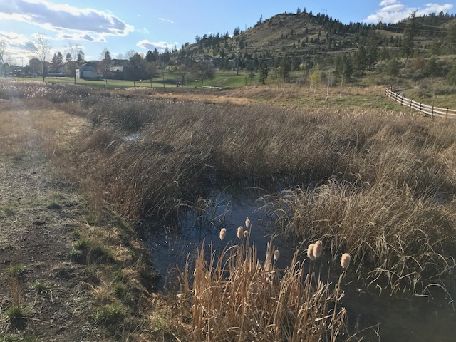
Figure 4: Photos of Dufferin Park Wetland – Right Side

- End of Journal Entry -

