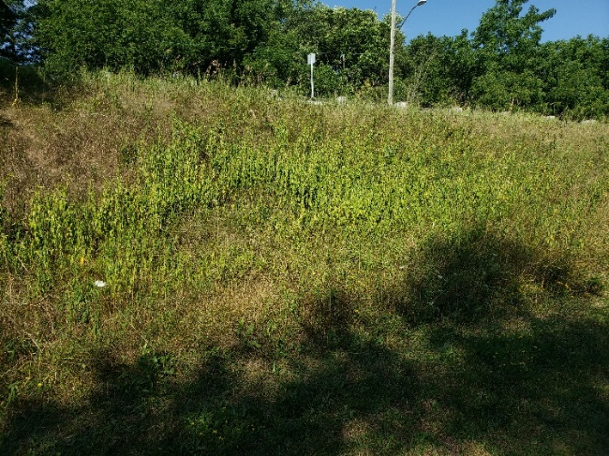
Figure 1: Dog strangling on east slope looking east
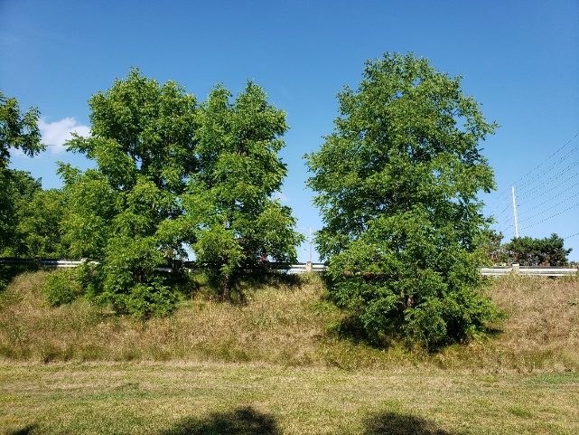
Figure 2: trees and grasses on east slope looking east
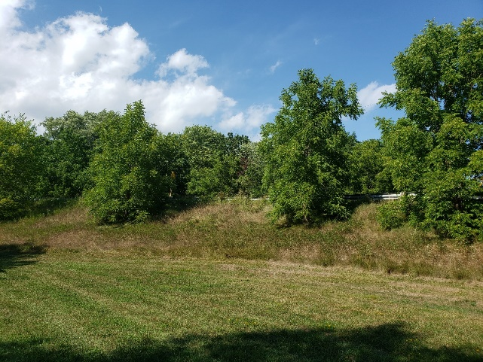
Figure 3: trees and grasses on eat slope looking north east
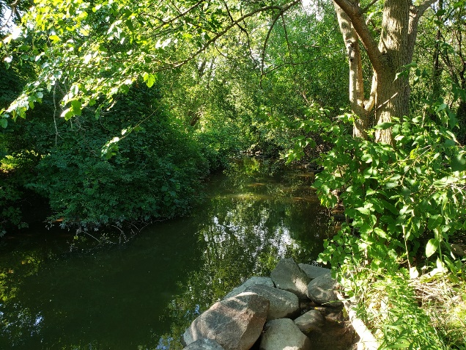
Figure 4: Harmony creek looking north
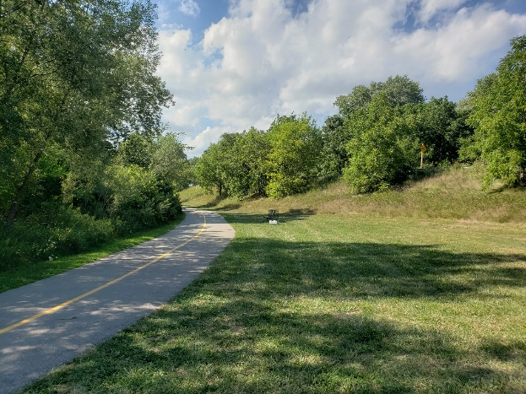
Figure 5: manicured grass east of trail looking north
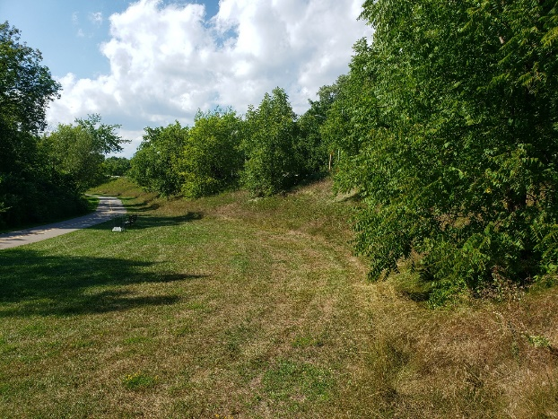
Figure 6: manicured grass looking north
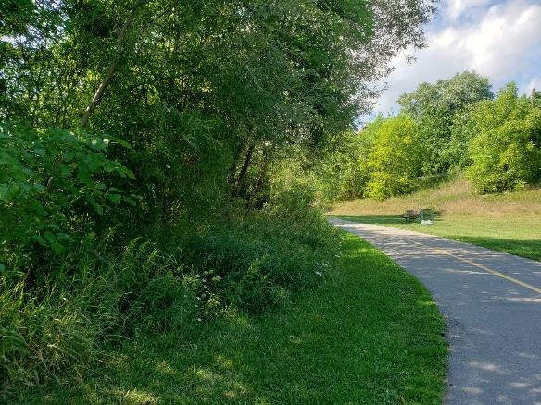
Figure 7: transition from bank vegetation to trail looking north
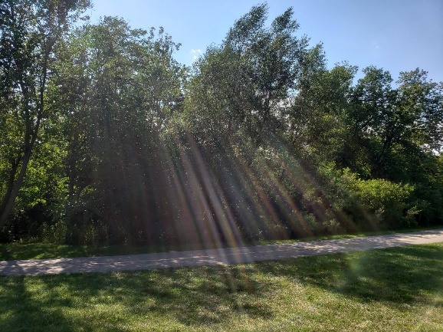
Figure 8: tree line along east bank of creek and trail looking west
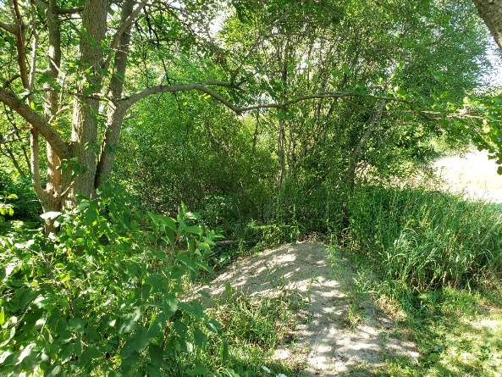
Figure 9: vegetated area between harmony creek and tail looking north.

