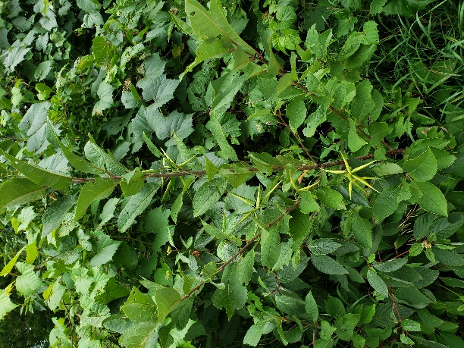
Figure 1: Example of vine growing in treed area.
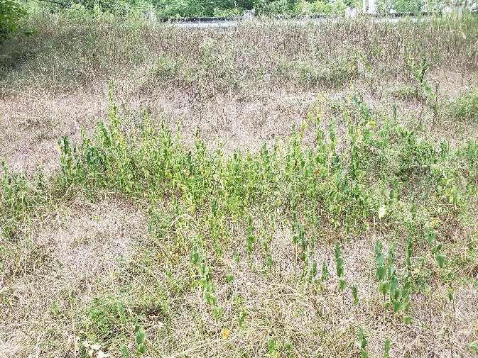
Figure 2: Example of vine growing on slope.

